|  |  |  |  |
| --- | --- | --- | --- |
| **Lyng Primary School Knowledge Organiser** | | | |
| **Topic:** | **The Vikings - Why did the Vikings leave Scandinavia?** | Year 6  Civilisation, Communication and Inventions | Autumn 1 |

|  |  |
| --- | --- |
| **What Step On and Goldilocks words will I use?** | |
| **Spelling** | **Definition** |
| Valley | A valley is a low [stretch](https://www.collinsdictionary.com/dictionary/english/stretch) of land between [hills](https://www.collinsdictionary.com/dictionary/english/hill), [especially](https://www.collinsdictionary.com/dictionary/english/especially) one that has a river flowing through it. |
| Plain | A plain is a large flat area of land with very few trees on it. |
| Physical geography | the branch of [geography](https://www.collinsdictionary.com/dictionary/english/geography) that [deals](https://www.collinsdictionary.com/dictionary/english/deal) with the natural [features](https://www.collinsdictionary.com/dictionary/english/feature) of the earth's surface |
| Human geography | the branch of geography dealing with how human activity affects or is influenced by the earth's surface |
| Flora | Plants of a particular region |
| Fauna | Animals of a particular region |
| Tundra | A vast, flat, treeless Arctic region in which the subsoil is permanently frozen. |
| Archipelago | An expansive group of islands |
| Sustainability | Avoidance of the depletion of natural resources in order to maintain an ecological balance |
| Glacier | A slowly moving mass or river of ice formed by the accumulation and compaction of snow on mountains or near the poles. |
| Subarctic | The region immediately south of the Arctic Circle. |
| Coast | Part of the land adjoining or near the sea. |
| Inland | Situated in the middle of a country – not by the sea |
| Picts | A member of an ancient people inhabiting northern Scotland during Roman times |
| Harvest | the process or period of gathering in crops |

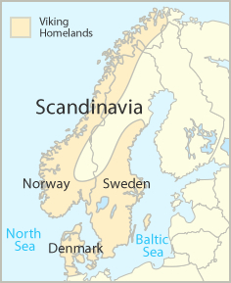

**Background information:**

Scandinavia is a group of countries in northern Europe, that includes Norway and Sweden. The term is most often used linguistically, to mean places that speak Scandinavian languages (also called the North Germanic languages). Then it also includes Denmark. The Scandinavian languages (Swedish, Norwegian, Danish, Icelandic and Faroese) are closely related, and many Scandinavians are able to understand some of the other languages, with some difficulty. Sometimes "Scandinavia" is a term of physical geography in which case it includes Finland instead.

**Enquiry questions that we shall investigate during the topic:**

**Fieldwork Opportunities**

* Viking Man – Seas



* OVERARCHING BIG QUESTION OF UNIT: Why did the Vikings leave Scandinavia?
* How did Scandinavia's landscape affect the Vikings? (P1)
* How did Scandinavia's landscape affect the Vikings? (P2)
* How did Scandinavia's climate affect Vikings?
* How does Norway differ to the UK?
* How is life different in Norway, Denmark and Sweden?

**Significant places**

* Norway
* Shetland Islands
* North Sea
* Hebrides

**Our Storytelling Approach to enhance engagement**

|  |  |  |
| --- | --- | --- |
| **People:**  A picture of Vikings in NorwayNorse boy (in training to be a Viking) | **Place:**  Norway to Lindisfarne  C:\Users\mia.wallace\AppData\Local\Microsoft\Windows\INetCache\Content.MSO\D9B20098.tmp | **Problem:**  Voyage from Norway to settle in Britain because of the lack of farming space on the western coast of Norway, the Vikings were obliged to set sail for new lands to find better soil. While the basis of many Viking raids was to plunder, they often had the motivation to set up colonies and kingdoms in which they could farm. |

**Map to be studied**

**Key facts and locations**

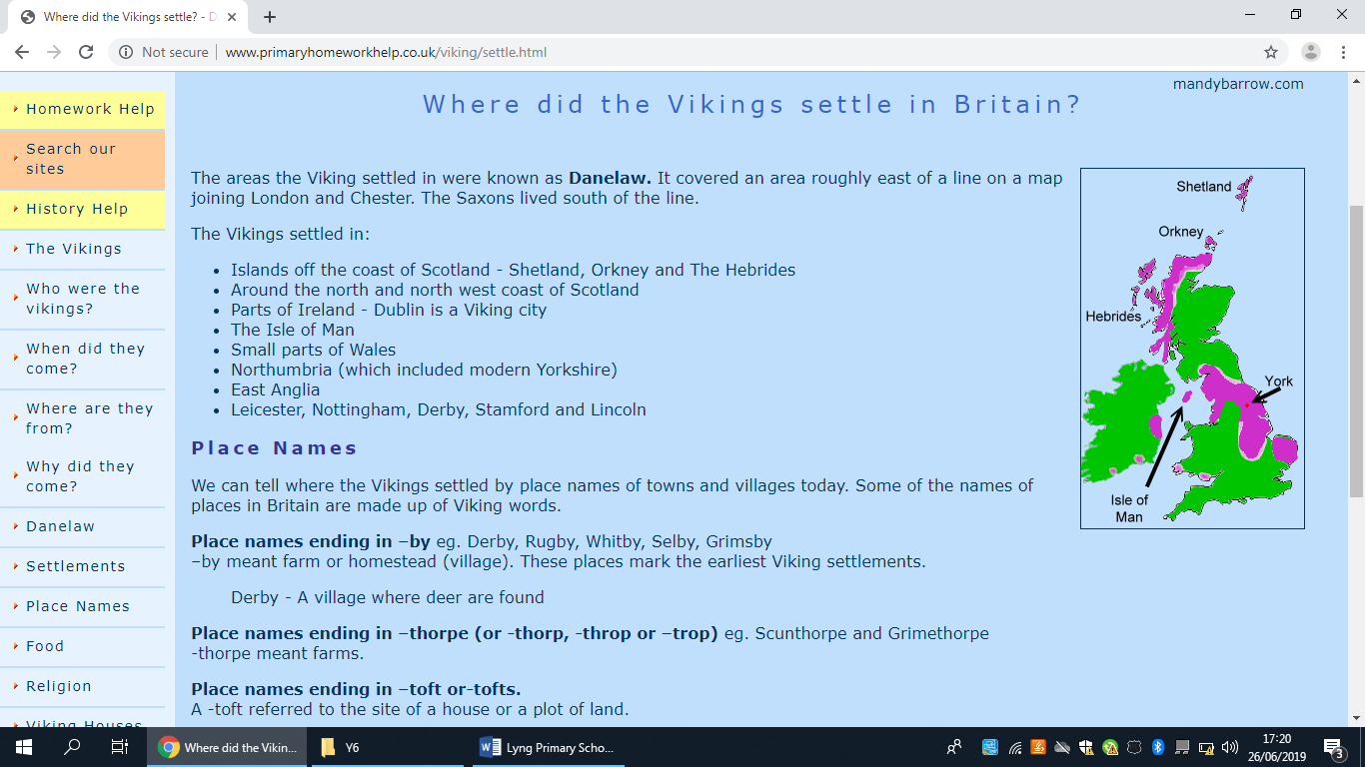

|  |  |
| --- | --- |
| **Norway** | **Lindisfarne** |
| * During winter, Norway's inland regions are colder than the coast because mountains block the warm. * Norway is one of the world's most northerly countries, and one of Europe's most mountainous countries. * Scandinavian mountains. * 460 metres (1,510 ft) and 32% of the mainland is located above the [tree line](https://en.wikipedia.org/wiki/Tree_line). * The country-length chain of peaks is geologically continuous with the mountains of [Scotland](https://en.wikipedia.org/wiki/Scotland) * The movement of the ice carved out deep [valleys](https://en.wikipedia.org/wiki/Valley), and when the ice melted, the sea filled many of these valleys, creating Norway's famous [fjords](https://en.wikipedia.org/wiki/Fjord). * Capital is Oslo. * Native plants: [holly](https://en.wikipedia.org/wiki/Ilex_aquifolium), conifer and [bell heather](https://en.wikipedia.org/wiki/Erica_cinerea). * Alpine tundra is common in Norway, covering a total of 32% of the land area. * [European windstorms](https://en.wikipedia.org/wiki/European_windstorm) with hurricane strength winds along the coast and in the mountains are not uncommon. For centuries one out of four males in coastal communities were lost at sea. * If they experienced a poor harvest season or bad weather, many starved during the harsh and long winters. For many Norsemen, fishing was widely practiced and local marine life often supplemented dietary needs not found in grains. * Summer storms stopped the movement of the Vikings to new lands and winter sea-ice is one of the causes of the first overwintering for raiding of the Norse on mainland Europe. * <http://www.medievalists.net/2017/09/weather-ruled-vikings/> (ice skating) | * Christian island – monastery * Lindisfarne is a small island located off the northeast coast of England. It is also known as Holy Island and is home to a priory and castle. * The island measures just over 4 km square and is almost 3 km from the mainland. * It can be reached by a causeway from the mainland of England at a low tide. |

**Agreed Outcome**

3D Relief Map of Scandinavia

|  |  |  |  |
| --- | --- | --- | --- |
| **Lyng Primary School Knowledge Quiz** | | | |
| **Geography Topic:** | **Why did the Vikings leave**  **Scandinavia?** | Year 6  *Civilisations, Communication and Inventions* | Autumn 1 |

|  |  |  |
| --- | --- | --- |
| 6. Why is the inland of Norway colder than the coast during winter? | **S** | **E** |
| Start:  End: | | |

|  |  |  |
| --- | --- | --- |
| 7. What is the capital of Norway? | **S** | **E** |
| Oslo |  |  |
| Helsinki |  |  |
| Copenhagen |  |  |

|  |  |  |
| --- | --- | --- |
| 8. Which continent is Norway part of? | **S** | **E** |
| Europe |  |  |
| North America |  |  |
| Africa |  |  |

|  |
| --- |
| 1. What do relief maps show? |
| S =  E = |

|  |
| --- |
| 1. Why were the Vikings able to adapt quickly to life in East England? |
| S =  E = |

**Our Viking Geography Quiz**

|  |  |  |
| --- | --- | --- |
| 1. What is an archipelago? | **S** | **E** |
| 1. An expansive group of islands |  |  |
| 1. A network of rivers |  |  |
| 1. A tropical storm |  |  |

Start of unit ___

End of unit ___

|  |
| --- |
| 1. List the three countries that combine to create Scandinavia. |
| Start :  End : |

|  |
| --- |
| 1. Give one reason that caused problems for farming for the Vikings? |
| Start :  End : |

|  |  |  |
| --- | --- | --- |
| 1. Which Scandinavia country has the greatest population? | **S** | **E** |
| Norway |  |  |
| Sweden |  |  |
| Denmark |  |  |
|  | | |
| 1. What’s a peninsula? | | |
| Start :  End : |  |  |